**Main Page or Front Page**

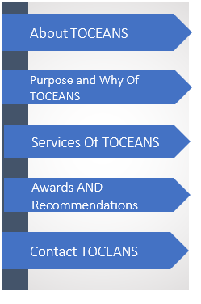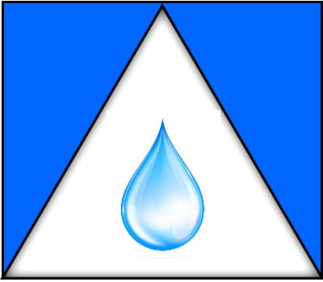

|  |
| --- |
|  |

**About TOCEANS Page**



Are WE drowning on the narratives placed on us?. What is the centre of who WE really are? How to get to the attribute of why WE are in this life Journey? Your key and resolution to these circumstances and situations is how TOCEANS was formed.

Dunstant is the Chief Empowerment Executive Strategist and founder of TOCEANS, he is a Servant Leadership Development Influencer, Coach, Speaker, Poet, Author and Mentor.

**Dunstant is Passionate about assisting others connect with:**

* Inspirational Core Value, with what makes you be YOU.
* Influencing your master mind attitude restructuring.
* Servant Leadership with root, reason and reaction.
* Life lesson learned through cause, action and reaction.
* Development and empowerment for your journey aided my mentorship.

**In TOCEANS exploration, it has been determined that our attitudes and differences, helps governs our thinking styles. Why and what we change defines or strategies to enhance, engage, empower, excite and enlighten us to make things better.**

**TOCEANS is all about Servant Leadership, Personality Dimensions to Succeed, and also to create journeys for others to grow, succeed and shine.**

**About the Speaker**

Dunstant’s educational background is in Mechanical Engineering, Strategic Management, Professional Management and Quality Assurance. He is specializing in seedership, servant leadership, dimensional mentoring and coaching. Dunstant Taylor is a Distinguish Toastmaster (DTM)x3, He is an experiences Motivational and Inspiration speaker, with strategic thinking styles and dimensional techniques for progression Dunstant main fun and passion are, to exploring your inner strength to creates growth and understanding, so others will shine. Dunstant love to create unique ideas and knowledge master minds, for your future journey in life, through Talents, Treasures and Time. His main goals and happiness, is to let others grow succeed and benefits from tactical changes, through Sowing, Services, Support and Sacrifice.



**PHILOSOPHY** **of TOCEANS --------Page**

**TOCEANS creativity and differential insight, works with you or your team, to Embryonic your potential, It`s Now!!!!!!!:**

**TOCEANS passionately believes we are limited by the items, situation, circumstances that we allowed to bound us, the crucial mind set to success and productivities, are already in our tool boxes.**

**TOCEANS empowerments is to walk besides you or your team, to show you the password to open you mind set, encourages you to excite self and also enables others.**

Insert Picture of a tree

Insert Picture of a Water Drop

Insert Picture of a Heart/Love sign

**TOCEANS Vision: TOCEANS Mission: TOCEANS Core Values:**

**PLANT A SEED and MAKE IT FLOURISH, ESSE QUAM VEDERI**

**(To be, rather to be seen) SERVENT LEADERSHIP, SUPPORT,**

**ENGAGEMENT & EMPOWERMENT**

**PROVIDE A WHEEL and LET OTHERS TRAVEL**

**PASSION a ATTRIBUTE and FUEL ENERGY TO EXCITE LIFE**

**---------------------------Add Picture -------------------------------------------------**



**“The WHY” and “The Purpose” of TOCEANS --------Page**

There are 5 fabulous, fantastic, fulfilled, Fruitful and forward-thinking woman in my life, that energized me to create TOCEANS, these 5 exceptional and empowering ladies morals, unique ideas and life processes, propels me to be a mentor, coach and support others to excel and shine.

It is out of their inner strength, growth for understanding, making others shine, creating positive ripple effect and exploring outcomes for others to be themselves and be one in a centre universe. These ladies are:

1. Mrs Elisabeth Dorother Babylove Taylor, (my late mum),
2. Mother Teresa (Catholic Saint), (Catholic Nun)
3. Mrs, Elizabeth Felicia Fejabie Taylor, (my late grandmother),
4. Princes Diana Frances Spencer, (late Princes Diana, Princess of Wales)
5. Mary Madeline (mother of Jesus)

My TOCEANS is empowerment, Influences, coaching, presentation or as a mentor is to create:

* TRANSFORMING to leave an unique ideas and knowledge for your future journey in life.
* **O**PPORTUNITIES to let you, your team or group shine and succeed in the journey of life.
* **C**ARING and providing hope, benefits and servant leadership for other journey in life.
* **E**NRICHING the “why” in you, your team or group in the journey of life.
* **A**SSISTING ------in the journey of life.
* **N**URTURING what makes you unique, different and belong in the journey of life.
* **S**HARING----- in the journey of life.

Remember it does not matter what stage you are in, think of it as a growth and improvement journey. Are you ready?

Connect your visions and concepts into reality. Advance your goals and intuitions into achievements. Nurture your thinking or thought processes into results. Remember every need, wants or need has an ego to feed.

* Growth Developments are key ingredient by your evidence of Life’s Lessons.
* Struggles are solved by your evidence of Life’s Learning.
* Problems are solved by your evidence of Life’s Wisdoms.
* Situations and Circumstances are key ingredients by your Life’s Journey
* The ``Why in our Life`` is the evidence of Life Understood.



**SERVICES OF TOCEANS --------- Page**

**TOCEANS will empower, entice, edify and engage you to: (do this in a quarterly circular form design, with symbol in the middle)**

**1 - Keynote Speaker, Presentation and Training**

**2 – Seedership towards Servant Leadership, and Growth and Planted Investment**

**3 – Charity, Treasures and Services**

**4 - Influencing and Directing your Master Mind**

TOCEANS your “WHY” in Life

Who is your “WHY” in your life Journey?

What is your “WHY” in your life Journey?

Where is your “WHY” in your life Journey?

How is your “WHY” in your life Journey?

When is your “WHY” in your life Journey?

Why is your “WHY” in your life Journey?

**\*\*\*\*\*Use step format graphic or picture to illustrate this section to show effect\*\*\*\*\*\*\*\*\*\***



**SERVICES OF TOCEANS --------- Page**

|  |  |  |
| --- | --- | --- |
| **Let your MESS be your message** | **Are you an ASSET or a Liability** | **What WAVE effect are we creating** |

**insert video clip here insert video clip here insert video clip here**

|  |  |  |
| --- | --- | --- |
| **The SEEDS we sow and grow** | **Why our PATHS will always have obstacles** | **Circumstances and Situations, are our best EDUCATION** |

**insert video clip here insert video clip here insert video clip here**



**AWARDS AND RECOMMENDATIONS TOCEANS**



**CONTENT INFORMATION PAGES**

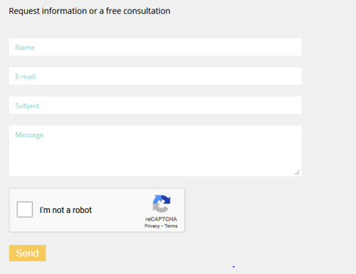**CONTENT INFO**

Phone:403-8629620

Email: info@toceans.ca